Tools

IDE : Android Studio 3.4.2

Language : Kotline - 1.3.41

Gradle: 5.1.1

Android Gradle Plugin Version: 3.4.2

Build Tool Version: 12.0.0

How to run

1. Open Project in Android Studio
2. Open **IssueTrackerUnitTest** andRun the Test

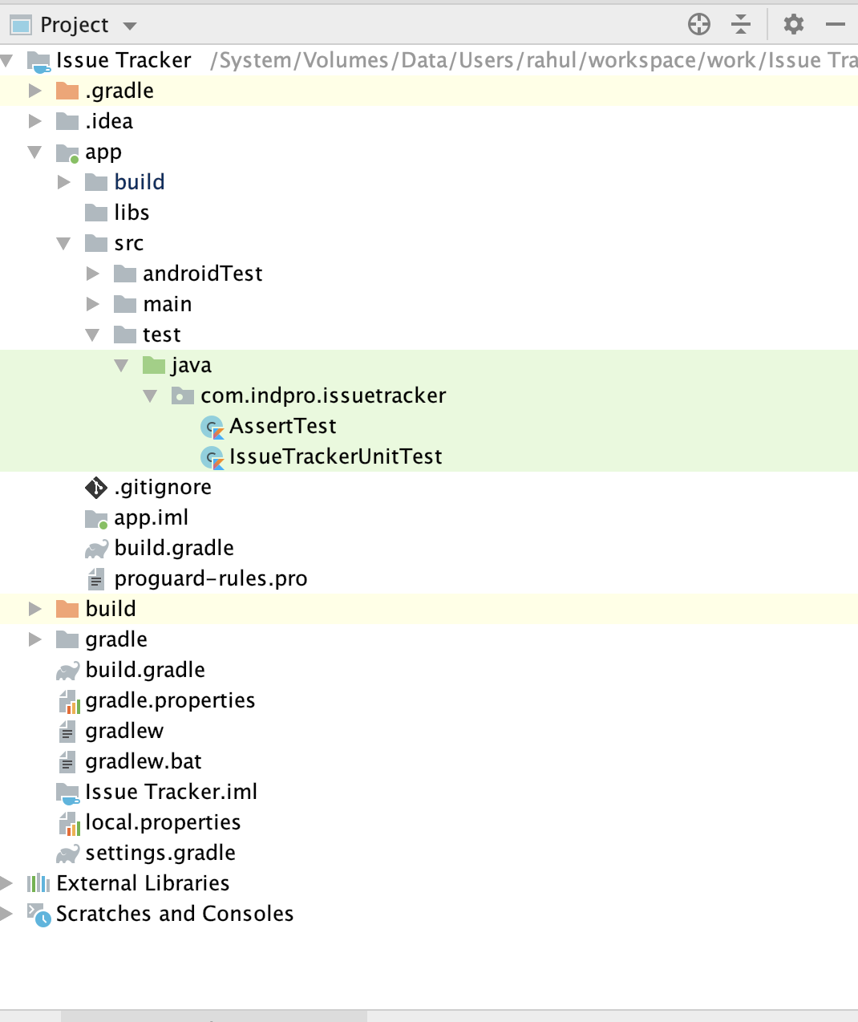

Operations has been implemented

* Add Issue
* Remove Issue
* Set Issue State
* Assign User to Issue
* Add Issue comment
* Get list of Issues
* Get a Specific Issue
* Add User
* Get list Of User
* Get a specific user

Using Set for store data

**Example**

**For User**

**val users = *hashSetOf*<User>()**

**For Issue**

**val issues = *hashSetOf*<Issue>()**

**Unit Test**

I have implemented unit test into **IssueTrackerUnitTest** file. You can find unit test file on zip folder.

These sort of testing has been performed

* Filter Issue
* Remove User - User will be removed from main list and Issue list
* removeTask
* randomTest - Pick a random task and assign it to a random user
* userTest - Fetch User list and filter data from the Issue list